# Nested loop C++ (Patterns):

Task 01:

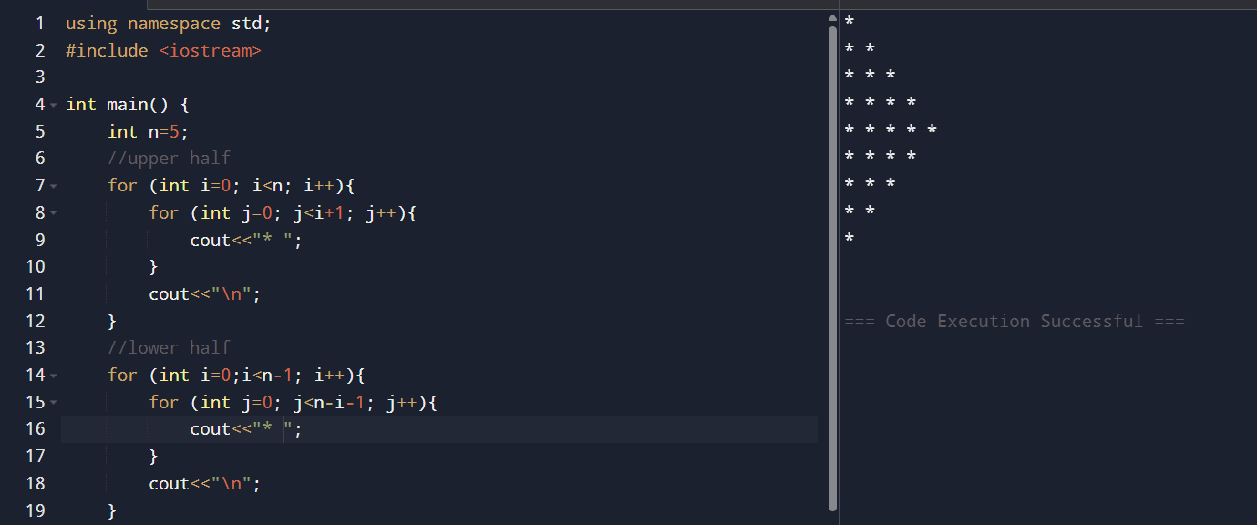

Task 02:

Task 03:

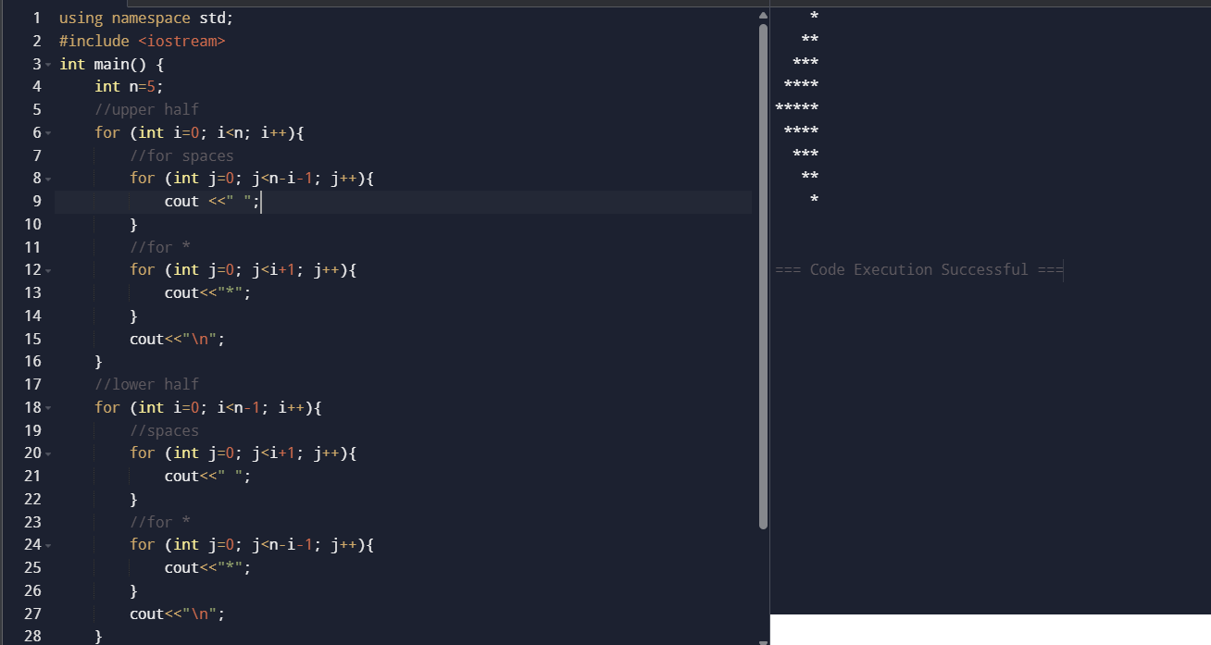

Task 04:

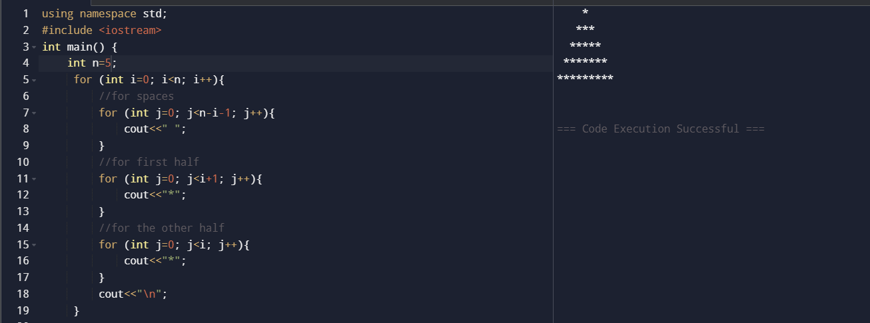

Task 05:

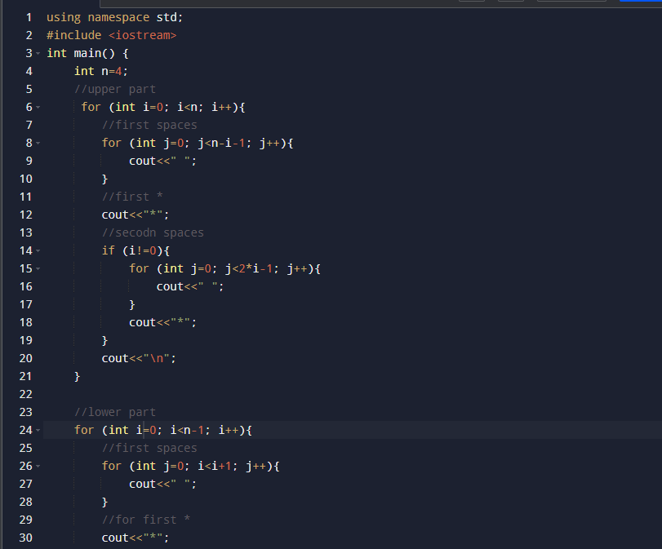

Task 06:

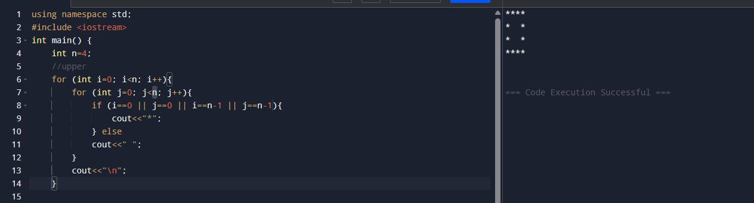

Task 07:

